Cihan Aydar

**Assumptions:**

1. Infinitely Permeable Core and Plunger
2. Neglecting fringing effect; so $Acore=Agap$.
3. Neglect leakage flux
4. Uniform flux distribution

$N.I=Rg. ∅g=Hg.lg$ $where Rg=\frac{l}{u.Ag}$

$$Then, Hg.lg=\frac{0,5}{4π.{10}^{-7}}*2*{10}^{-2}=8000 A.t;$$

$Bg=0.5T$

From assumption 2 and 3, Inductance depend on the geometry of the system, turn ratio and permeability constant of air. Here, we are in linear region and area in which magnetic flux pass through A is assumed to be $2 br^{2}$. So,

$L=\frac{λ}{i}=\frac{N^{2}}{R}=\frac{1^{2}}{\frac{2}{2.4π.{10}^{-7}}}=1.25uH$

$$L\left(x\right)=\frac{N^{2}}{R}=N^{2}.u.\frac{Agap}{2g}=1^{2}.4π.{10}^{-7}.\frac{(2-x)}{2.0,05}=25*{10}^{-6}*\left(1-\frac{x}{2}\right)(H)$$

$Wfld=\frac{1}{2}.L\left(x\right).i^{2}=\frac{1}{2}*25*{10}^{-6}*\left(1-\frac{x}{2}\right)*{8000}^{2}=800*\left(1-\frac{x}{2}\right) (J)$

$$ffld=\frac{1}{2}.i^{2}.\frac{dL\left(x\right)}{d\left(x\right)}.=800*\frac{d\left(1-\frac{x}{2}\right)}{dx}$$

where $0<x<2$.

After analitical calculations, I simulated c-core in ANSYS Maxwell program as following.

1. ur=1000 for core and plunger, no saturation;

As seen, magnetic circuit tries to **maximize the inductance**, ,in other words to **minimize the reluctance** and **to increase co-energy of system**. At x=7cm, force changes sign (+) and tries to have maximum inductance again.

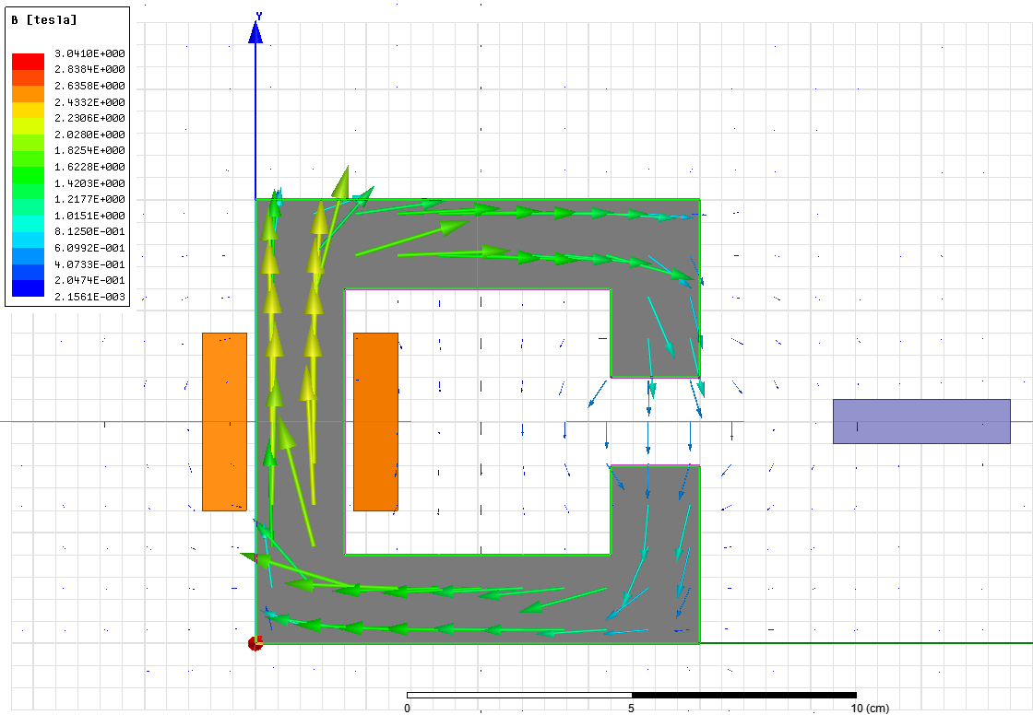

Figure 1 Flux Density Vector Distribution (x=13cm)

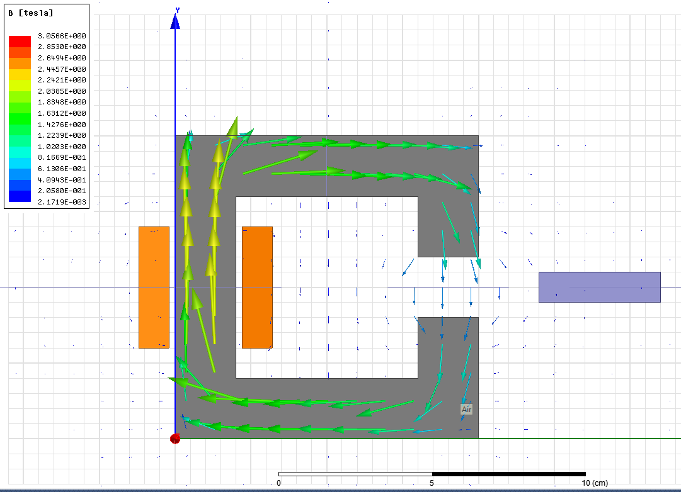

Figure 2 Flux Density Vector Distribution (x=12cm)

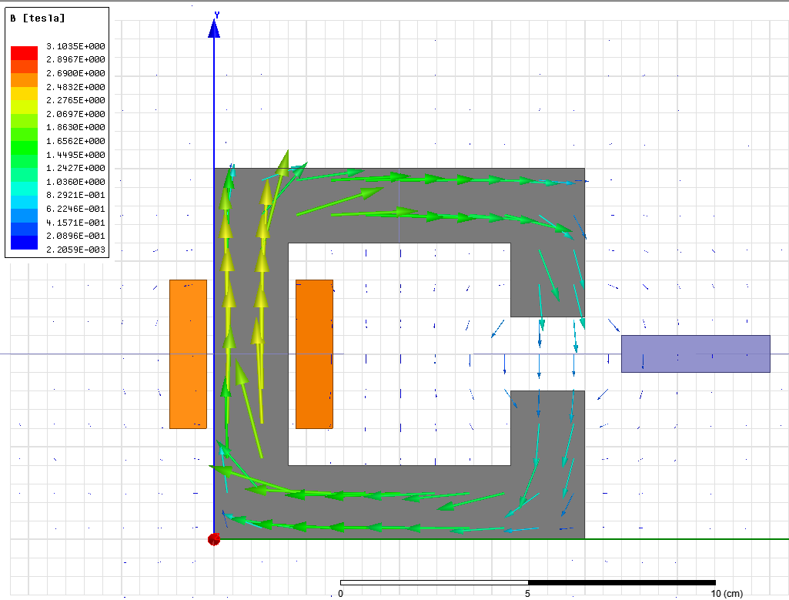

Figure 3 Flux Density Vector Distribution (x=11cm)

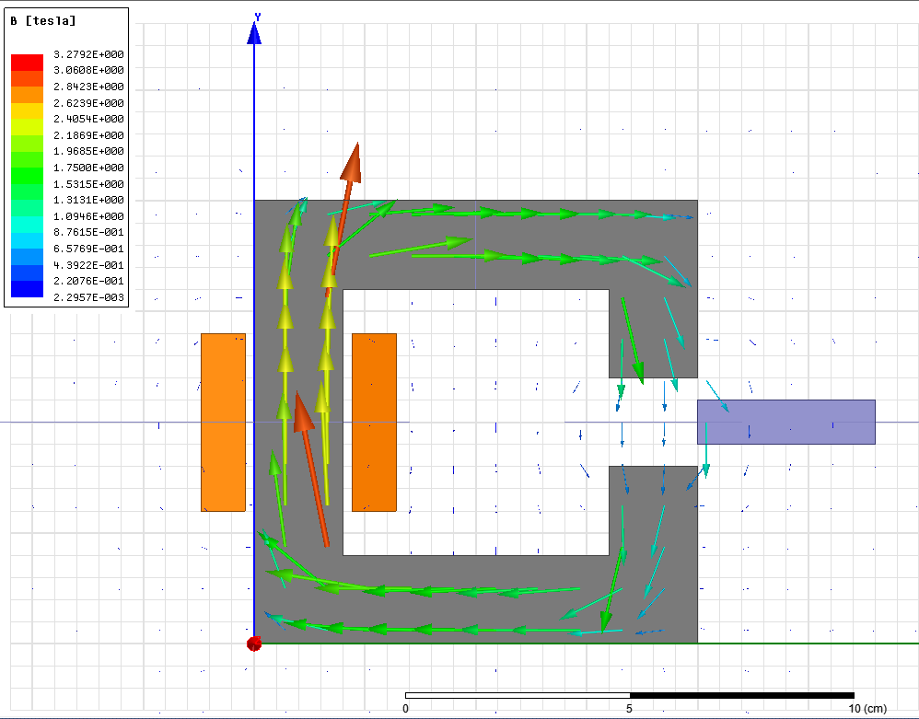

Figure 4 Flux Density Vector Distribution (x=10cm)

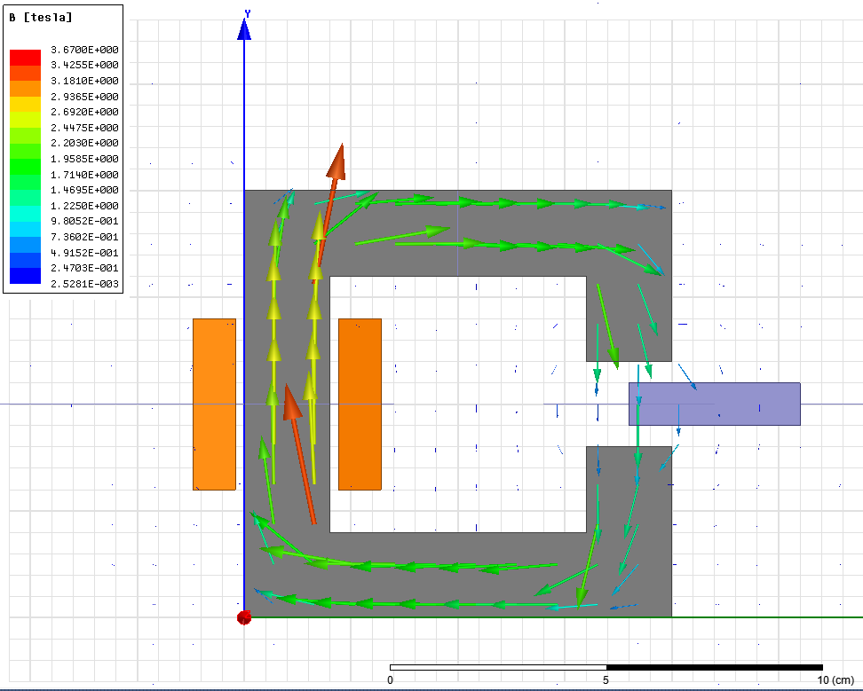

Figure 5 Flux Density Vector Distribution (x=9cm)

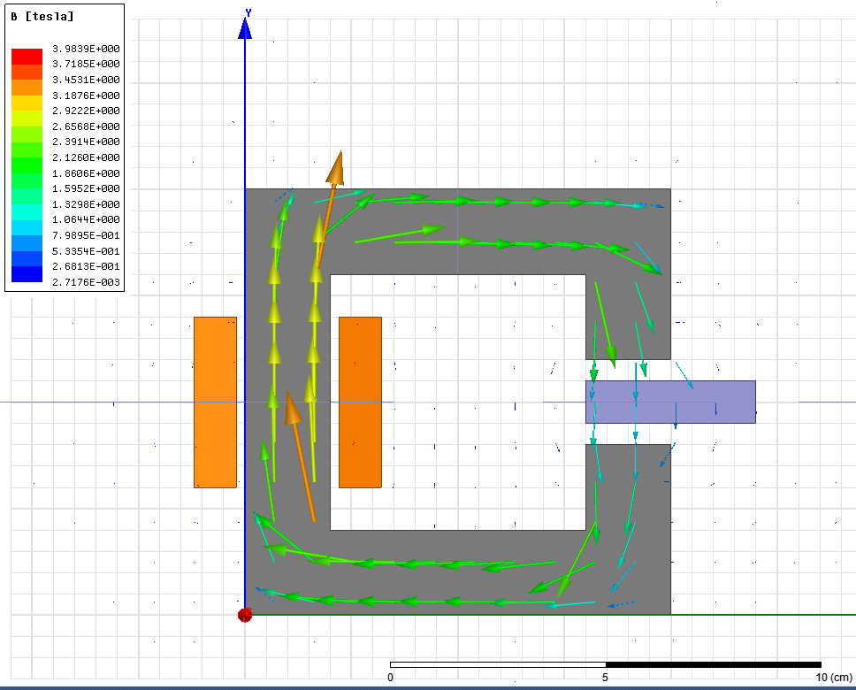

Figure 6 Flux Density Vector Distribution (x=8cm)

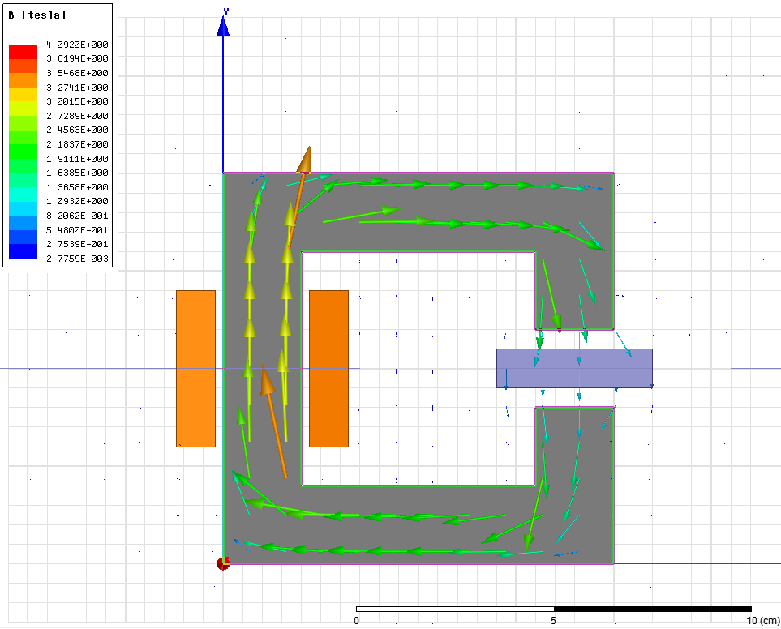

Figure 7 Flux Density Vector Distribution (x=7cm)

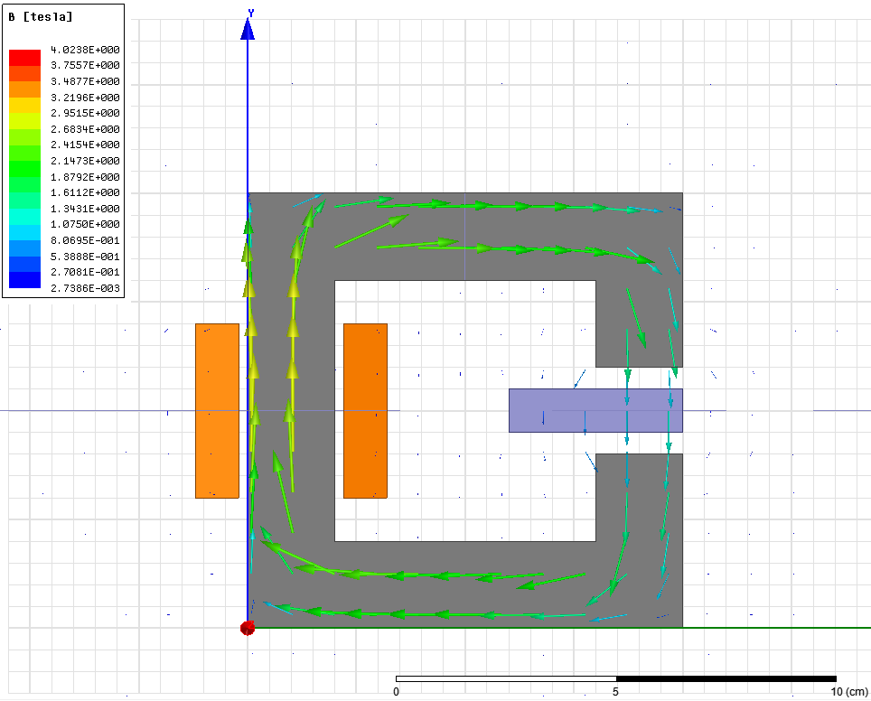

Figure 8 Flux Density Vector Distribution (x=6cm)

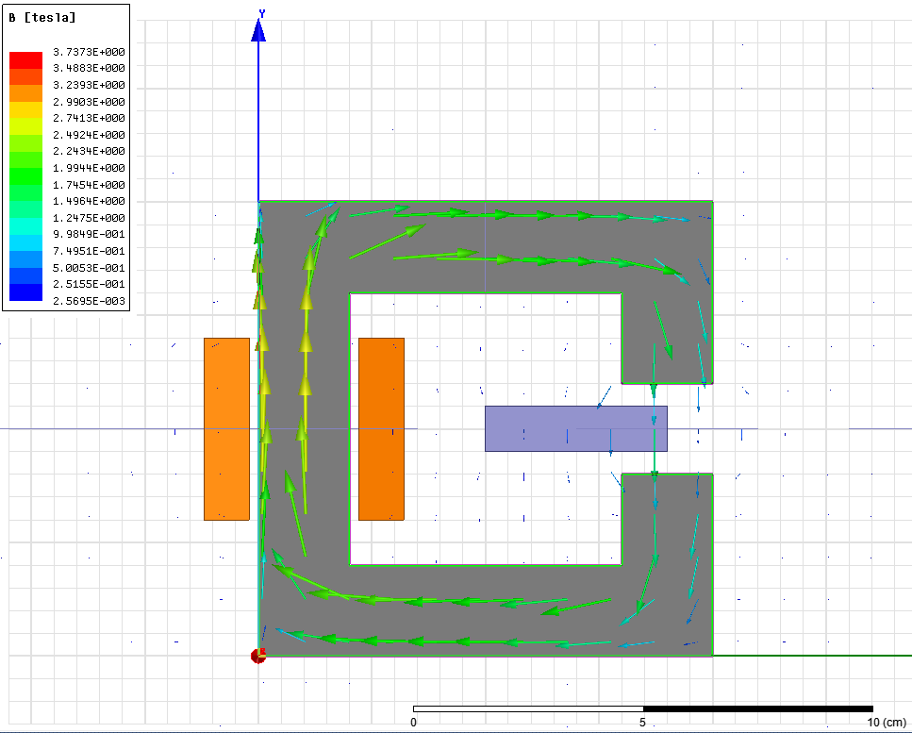

Figure 9 Flux Density Vector Distribution (x=5cm)

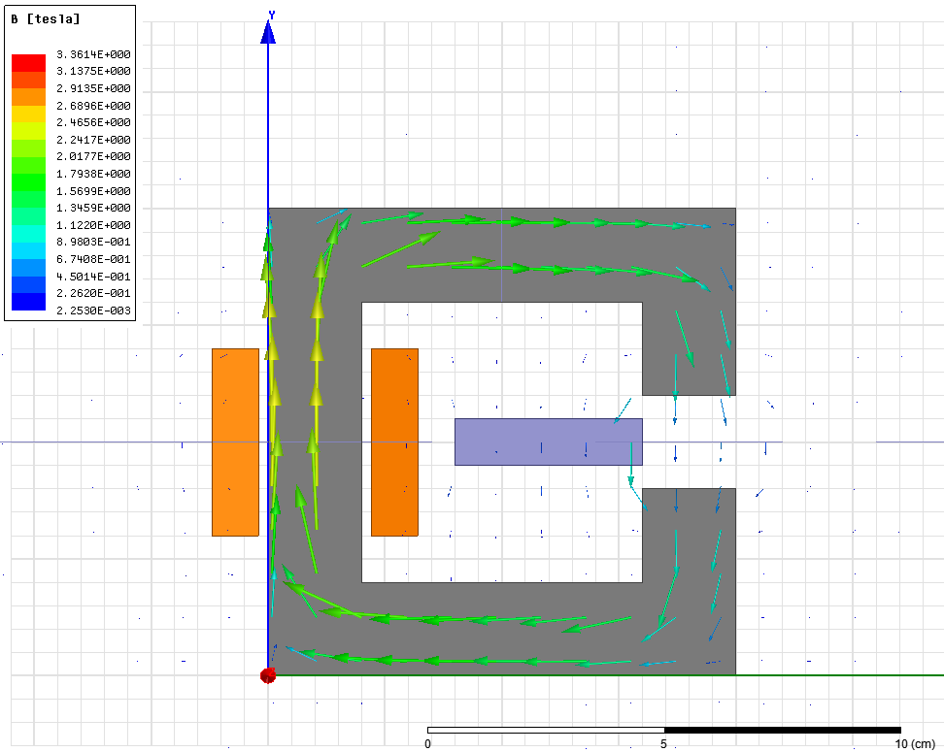

Figure 10 Flux Density Vector Distribution (x=4cm)